H.T No
Regulations:
A20

Sreenidhi Institute of Science and Technology
(An Autonomous Institution)
Code No: 8AC42 Date: 29-Mar-2023 (AN)

B.Tech I-Year I- Semester External Examination, March/April-2023 (Supplementary)
ELECTRICAL CIRCUITS AND NETWORK ANALYSIS (ECM)

Time: 3 Hours Max.Marks:70

Note: a) No additional answer sheets will be provided.
b) All sub-parts of a question must be answered at one place only, otherwise it will not be valued.
c) Missing data can be assumed suitably.
Bloom's Cognitive Levels of Learning (BCLL)

Remember | L1 | Apply | L3 | Evaluate | L5
Understand | L2 | Analyze | L4 | Create | L6

Part - A Max.Marks:20

Answer all QUESTIONS.

 |  | BCLL | CO(s) | Marks
1 | State KCL and KVL. | L1 | CO1 | [2M]
2 | Define Form factor and Peak factor for a Sinusoidal Waveform. | L2 | CO2 | [2M]
3 | State Faraday’s Laws of electromagnetic Induction. | L2 | CO3 | [2M]
4 | State Millman’s Theorem. | L2 | CO4 | [2M]
5 | Define Port and Two-port network. | L1 | CO5 | [2M]
6 | Define a time constant for an RL series circuit. | L1 | CO6 | [2M]
7 | Explain about a Supermesh. | L2 | CO1 | [2M]
8 | State Thevenin’s Theorem. | L2 | CO4 | [2M]
9 | Sketch the DC response of RC circuit and response curve. | L1 | CO6 | [2M]
10 | Explain about Composite magnetic circuit. | L1 | CO2 | [2M]

Part – B Max.Marks:50
ANSWER ANY FIVE QUESTIONS. EACH QUESTION CARRIES 10 MARKS.

 |  |  | BCLL | CO(s) | Marks
11. | a) | Use Mesh Analysis to obtain i_{1,} i_{2,} i₃ for the circuit shown in Figure  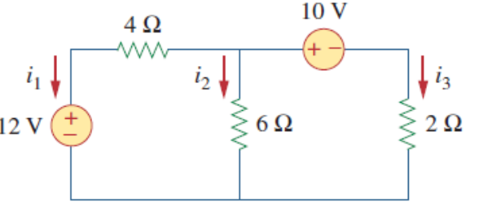 | L3 | CO1 | [5M]
 | b) | Find the equivalent resistance between the terminals A and B of the network shown in Figure. by using star/delta transformation.  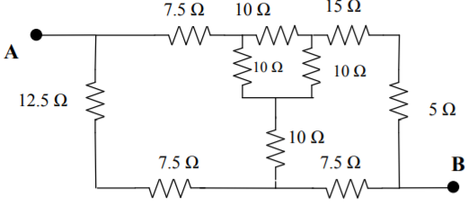 | L3 | CO1 | [5M]
12. | a) | A current of 4 A flows through a non-inductive resistance in series with a choking coil when supplied at 230 V, 50 Hz. If the voltage across the resistance is 100 V and across the coil is 180 V, draw the phasor diagram and calculate (i) impedance, reactance and resistance of the coil  (ii) the power absorbed by the coil (iii) the total power. | L4 | CO2 | [5M]
 | b) | An alternating current is represented by i = 50 sin 314 t. Determine  (i) Average value (ii) RMS value (iii) Peak factor (iv) Form factor. | L3 | CO2 | [5M]
13. | a) | Bring out an analogy between magnetic circuits and electric circuits. | L2 | CO3 | [5M]
 | b) | A ring shaped electromagnet has an air gap of 6 mm and 20 cm² in area, the mean length of the core being 50 cm and its cross section is 10 cm². Calculate the ampere-turns required to produce a flux density of 0.5 Wb/m² in the gap. Assume the permeability of iron is 1800 | L2 | CO3 | [5M]
14. | a) | Determine the maximum power delivered to the variable resistor R shown in the following circuit.  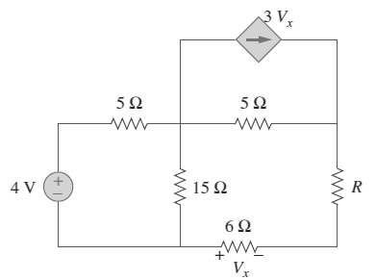 | L4 | CO4 | [5M]
 | b) | Use super position theorem to find the current I in the circuit.  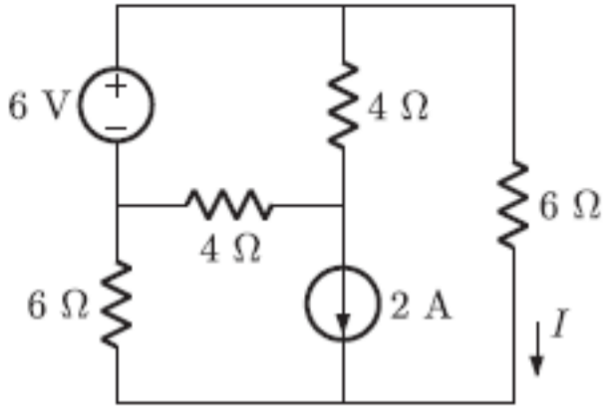 | L4 | CO4 | [5M]
15. | a) | Determine the h parameters for the circuit shown below.  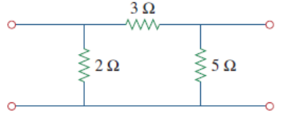 | L3 | CO5 | [5M]
 | b) | Express the ABCD parameters of a Two port network in terms of Z parameters. | L2 | CO5 | [5M]
16. | a) | Find v(t) for t>0 in the circuit shown. Assume the switch has been open for a long time and is closed at t = 0. Calculate v(t) at t = 0.5 sec.  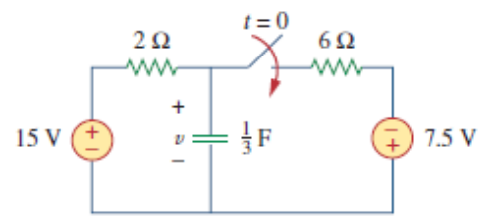 | L3 | CO6 | [5M]
 | b) | Determine the step response of an R-L-C series circuit using differential equation approach. | L3 | CO6 | [5M]
17. | a) | Derive the expression for star to delta transformation for a given network. | L2 | CO1 | [4M]
 | b) | Explain quality factor in Resonating Circuits. | L2 | CO2 | [3M]
 | c) | What is meant by Self and Mutual Inductance. | L2 | CO3 | [3M]
18. | a) | State Norton’s Theorem. | L2 | CO4 | [4M]
 | b) | What is the condition for Reciprocity and Symmetry. | L2 | CO5 | [3M]
 | c) | Define time constant of R-C circuit excited DC source. | L2 | CO6 | [3M]

-- 00 -- 00 –

